**Accepted Manuscript**



Raspberry Pi assisted face recognition framework for enhanced law-enforcement services in smart cities

Muhammad Sajjad, Mansoor Nasir, Khan Muhammad, Siraj Khan, Zahoor Jan, Arun Kumar Sangaiah, Mohamed Elhoseny, Sung Wook Baik

PII: S0167-739X(17)30951-2

DOI:https://doi.or[g/10.1016/j.future.2017.11.013](https://doi.org/10.1016/j.future.2017.11.013) Reference: FUTURE 3805

To appear in: *Future Generation Computer Systems*

Received date : 9 May 2017

Revised date : 10 October 2017

Accepted date : 7 November 2017

Please cite this article as: M. Sajjad, M. Nasir, K. Muhammad, S. Khan, Z. Jan, A.K. Sangaiah, M.

Elhoseny, S.W. Baik, Raspberry Pi assisted face recognition framework for enhanced law-enforcement services in smart cities, *Future Generation Computer Systems* (2017), https://doi.org/10.1016/j.future.2017.11.013

This is a PDF file of an unedited manuscript that has been accepted for publication. As a service to our customers we are providing this early version of the manuscript. The manuscript will undergo copyediting, typesetting, and review of the resulting proof before it is published in its final form. Please note that during the production process errors may be discovered which could affect the content, and all legal disclaimers that apply to the journal pertain.

Raspberry Pi Assisted Face Recognition Framework for Enhanced Law-Enforcement Services in Smart Cities

1Muhammad Sajjad, 1Mansoor Nasir, 2Khan Muhammad, 1Siraj Khan, 1Zahoor Jan, 3Arun Kumar Sangaiah, 4Mohamed Elhoseny, 2Sung Wook Baik*

1Digital Image Processing Laboratory, Department of Computer Science, Islamia College Peshawar, Pakistan

2Intelligent Media Laboratory, Department of Software, College of Software and Convergence Technology, Sejong University, Seoul, Republic of Korea

3School of Computing Science and Engineering, VIT University, Vellore, India

4Department of Computer Science and Engineering, University of North Texas, Denton, Texas, USA

# Abstract

Similar to a fingerprint search system, face recognition technology can assist law enforcement agencies in identifying suspects or finding missing persons. Face recognition technology lets the police detect a suspect’s face and compare it with image databases of known criminals and provides investigators with a match list of the most similar faces. Face recognition is a highly efficient and accurate tool in investigation processes. However, in some sensitive scenarios covert methods are required for the detection of suspects or missing persons without risking the lives of police. With the availability of the nano devices such as Raspberry Pi, law enforcement agencies such as police can be equipped with a concealed and secure face recognition system. In this paper, a Raspberry Pi and cloud assisted face recognition framework is proposed. A small-sized portable wireless camera is mounted on a police officer’s uniform to capture a video stream, which is passed to Raspberry Pi for face detection and recognition. The proposed method uses Bag of Words for extraction of oriented FAST and rotated BRIEF points from the detected face, followed by support vector machine for identification of suspects. Raspberry Pi has limited resources such as storage space, memory, and processing power, and therefore the proposed classifier is stored and trained on the cloud. The proposed method is implemented on Raspberry Pi 3 model B in Python 2.7 and is tested on various standard datasets. Experimental results validate the efficiency of the proposed method in accurate detection of faces compared to state-of-the-art face detection and recognition methods, and verify its effectiveness for enhancing law-enforcement services in smart cities.

# Keywords

IoT and Smart Cities, Face Recognition, Video Processing, Image Prioritization, Machine Learning, Multimedia

# Introduction

In recent years, with the explosive growth of smart devices, a change in user preferences has been observed [1]. Advancement in recent technologies like 3G/4G networks help users connect to the grid from remote locations and enjoy a richer user experience with a wide spread use of social networking features [2]. Such services can be exploited to make the work of security agencies more manageable and reliable. Law enforcement agencies usually encounter problems when it comes to public surveillance and suspect detection, as it is not an easy task especially in third world countries where budgets are limited and solutions for thwarting crimes can be very expensive and harder to implement. Therefore, cheap and simple solutions for suspect detection is becoming increasingly challenging to ensure public security and to deliver security services regardless of time and place. The proposed system is a step towards modern public security solutions remotely in a cost-effective way in smart and emerging cities.

Face recognition is becoming a multi-disciplinary research area and it has vast applications in the field of security, i.e. identification and verification of a person in image/video frames. Identifying humans from faces is what humans do implicitly and we are quite good at it. However, when it comes to computers, it is not an easy task for image processing applications as there are several parameters that need to be calculated precisely before recognition [3]. Over the past several years, the face recognition technology has engaged an overwhelming number of researchers and it is slowly replacing other biometrics security systems [4-6]. This is mainly due to its capability to record at a distance without interacting with the subject itself, making it convenient for a wide range of applications. Face recognition systems range from criminal detection in national databases to social media websites, and is also used for the identification of suspects on international borders [7].

The human face is regarded as a good metric for identification along with other biometric techniques such as fingerprints and irises. In most cases, the face provides sufficient information to identify any suspect to a reliable extent [8]. Although other biometric techniques such as fingerprint scanning are generally more accurate than face recognition, face recognition methods are advantageous due to the fact that they do not require the cooperation of the suspect. A number of techniques exist in the literature that can be used for face recognition. For instance, Yang et al., [9] presented an appearance- based face representation and recognition system using two dimensional PCA. This technique makes use of a 2D matrix as opposed to a 1D vector for vector covariance. This method claims to be less resource intensive and suitable for smaller image size. This method does not address the problems of illumination, variation, or pose directly, and therefore its performance and robustness is somewhat predictable. However, in real-world situations, images are prone to damage like scratches, blurring, or distortions. Kshirsagar et al., [10] used the Eigen faces technique which makes use of linear discriminant analysis [11]. LBP based descriptors are usually effective in representing spatial

structure information and it has been successfully applied to face recognition with good results. The simplicity in computation as well as low-dimensional space requirement makes it ideal for small problem size; however, the redundancy in features and increasing feature length leads to compromised accuracy.

Besides the above, the hidden morrow model [12] has also been used for features extraction and face recognition but due to the high computational demand and lag in performance, it cannot be reliably used in real-time situations. Recently, researchers used artificial neural networks [13] and convolutional neural networks (CNNs) [14] which provide better results in both face detection and recognition. Additionally, some machine learning techniques such as classification can be used to classify faces to their respective classes. Linear SVM [15] is a classifier most commonly used for binary classification which can also be used for multi-class classification [16] with some variations.

The aforementioned methods are computationally expensive, making them less suitable for real-time detection and recognition of faces during public surveillance. Therefore, the proposed framework uses Bag of Words with the ORB (Oriented FAST and Rotated BRIEF) [17] feature extraction method for feature extraction which is cost-effective, thus making it more feasible for our system. Further, our framework uses a cloud-based ensemble support vector machine (ESVM) to recognize the suspects. This type of recognition uses 1012 vectors to train the model and identify suspects later on with good accuracy. The main original contributions of this work are listed as follows:

* 1. A novel Raspberry Pi based cloud assisted framework is proposed for suspect detection and recognition. Suspects are identified in video streams which passively facilitate law enforcement agencies to provide better safety in smart cities.
  2. The Viola Jones face detector is incorporated in the proposed framework, providing efficient face detection results compared to state-of-the-art schemes. Furthermore, the Viola Jones face detection algorithm is computationally inexpensive, making it suitable for the Raspberry Pi based framework.
  3. The proposed system considers ORB points as extracted from the detected face region for face recognition. The ORB technique uses a fast binary descriptor based on BRIEF, and is rotationally invariant. Further, it is effective and computationally feasible for embedded and smart devices such as smart phones, tablets, and Raspberry Pi, where resources are limited.
  4. Our framework uses an SVM model which is trained on the cloud to recognize faces and categorize them into their respective classes. Instead of sending entire face images, only extracted features are transmitted to the cloud server, saving transmission energy and bandwidth. This makes our system more affordable and implementable for security in smart cities.
  5. Securing the features of a query image is not necessary because the image cannot be recreated from the limited set of features. However, for an added layer of security we calculate the hash of each vector using the SHA-128 algorithm. This creates a 128-bit hash for a given vector that is then transferred to the cloud implicitly, along with the feature vector to provide integrity and confidentiality. Similar security mechanisms are proposed in our previous works [17-19] where we proposed methods of encrypting medical images using stenographic techniques on cloud in resource constrained devices.

The rest of the paper is organized as follows: Section 2 reviews related works, followed by Raspberry based applications for smart cities. The proposed work is explained in Section 3. Experimental results and discussion are given in Section 4. The conclusion and future research directions are given in Section 5.

# Literature Review

This section reviews state-of-the-art schemes for face detection and recognition in public security applications for law-enforcement agencies. In recent years, various public security applications for public safety such as remote traffic monitoring and tele-security services have been developed, utilizing smart phones and tablets. The gradual advancement of techniques for face identification have been presented to explore their role in suspect detection because suspect identification plays a vital role in thwarting crimes by detecting criminals to reduce crimes and provide safety for the public.

There are many algorithms that can automatically detect a face in an image/video frame, e.g. a cascading object detector, but the Viola Jones algorithm is one of the most popular for face detection [20, 21]. Faces are easily cropped from an image/video frame using the face detection algorithms. Facebook uses a deep-face system in which a 3D face model is employed to apply a piecewise affine transformation [22]. A nine-layer deep neural network is used to derive a face. Their system is trained with the largest labeled dataset of four million faces belonging to four thousand individuals and a simple classifier reaches an accuracy of 97.35% [23]. A new feature extraction method is used for face recognition that uses Hough transform peaks [24]. These peaks are used for feature extraction and binary particle swarm optimization (BPSO) is used for selecting optimal features from the feature vector. The testing image is then classified using the Euclidean classifier. The Euclidean distance of a new Eigen face between the stored Eigen faces, and the lowest Euclidean distance between the new Eigen face and the stored Eigen face is considered the matched face [25]. Learned Local Gabor Patterns (LLGP) is a technique used for face representation and recognition. This technique is based on Gabor features, which makes use of intensity mapped masking to reduce the intensity of the background of a face image. The edges are improved using a Laplacian of Gaussian filter, while BPSO is used for optimal features selection and the Euclidean classifier is used for classification [26].

A 2D Laplacian face method is used for feature extraction, which is more accurate than one dimensional Laplacian faces, and KNN is used for classification purposes [27].

A novel feature extraction method for face images has many advantages over other traditional feature extraction methods, and these features are particularly suitable for face recognition when used with the KNN classifier for classification. A face recognition system that uses the Scale Invariant Feature Transform (SIFT) [28] algorithm is used for the extraction of features from faces. These features are robust and fast but are weaker, and the algorithm requires more time to process than SURF [29]. In the proposed work, the ORB technique is used for feature extraction, which uses a fast binary descriptor based on BRIEF and is rotationally invariant. ORB is suitable in the proposed framework because it is extremely cost effective and computationally feasible for embedded and smart devices such as smart phones, tablets, and Raspberry Pi, where resources are limited. Experimental results demonstrate that the ORB feature extraction method is more efficient on a Raspberry Pi based framework for suspect recognition in comparison with state-of-the-art SIFT and SURF. In the following section we investigate some real world applications designed by enthusiasts and researchers to facilitate daily life challenges. The versatility and diversity of the Raspberry Pi system makes it easy for developers to create useful, dynamic, and intelligent solutions for real world problems.

# Raspberry Pi based Applications

In the last few years, a significant amount of research work has been done using Raspberry Pi and other Nano (smart) devices. Chowdhury et al., [30] developed a home automation solution that facilitates the everyday activities of the home owner by automating doors, the home electric grid, and other appliances. All these operations can be controlled via the Internet using web services. Xu et al.,

[31] presented a test bed for wireless sensor nodes using RPi, making use of several logistic regression techniques to make routing more intelligent. Shah et al., [32] introduced a new application of Raspberry Pi using the Internet-of-Things (IoT). These applications of Raspberry Pi, combined with computational resources provided by the cloud, have opened new opportunities for richer applications and user experiences.

Agrawal et al., [33] presented a low-cost irrigation and water management solution that is energy efficient and serves as a proof of concept. The initial setup makes use of some scalar sensors like ultrasonic sensors and solenoids to water some 50 pots in a garden, but the design can potentially be used to irrigate large fields as well. Januzaj et al., [34] developed a security access control application based on face recognition. Due to its versatility, the Raspberry Pi device is popular among researchers. With its programmable pins, low cost, and easy to use software, some interesting projects have been proposed recently. In the medical field, Sethia et al., [35] proposed a method of transferring patient information more securely to repositories. The author used an ABE based encryption

technique that encrypts data using a custom designed java applet that ran on Raspberry Pi. Raspberry Pi and which has been immensely popular in the Internet-of-things (IoT) too. For instance, Imteaj et al., [36] used the device to design an automatic fire alarm system for warehouses and custom designed it for a garment factory. Furthermore, the system also sends an SMS along with evidence of the damaged area in the form of a picture. The fire brigade is also informed autonomously and special care has been taken to ensure fewer false alarms. Due to the small size of the device, it can be placed in a very confined space. For example, Chungki et al., [37] used the Raspberry Pi to act as an automatic charging mechanism for drones and quad copters. Similarly the same device is used by [38] to balance power loads among power meters. The authors introduced a new technique based on computer-network load balancing. They claim to have successfully implemented the technique and had profound results.

# Support Vector Machine

Support Vector Machine is one of the most famous classifiers used in many classification problems. The reason for being used so widely is its simplicity and ease in implementing details. The reason that we chose SVM as classifier is that its performance on small devices with limited resources is implacable. SVM has been used by many researchers in the past and proved its significance over the other classifiers available [39]. There are other variants of SVM such as Fuzzy SVM and LS-SVM but the performance to accuracy ratio of the original SVM is very good in most cases. The SVM classifier has been used by many researchers in dynamic areas such as medical image classification[40-42], fruit classification[43], and face recognition [44]. Comparative study of SVM variants has not been conducted on Raspberry Pi yet, and choosing the optimum variant is still an open issue. The accuracy achieved by our experiments are comparatively better and investigation of all the other variants is beyond the scope of this paper.

# Proposed Methodology

Raspberry Pi cloud-based face detection and recognition is an advanced technology, which can enable law-enforcement agencies to easily identify different suspects locally and remotely in a seamless way. Raspberry Pi cloud based face detection and recognition can be operated through the local system as well as in the cloud. The proposed system will help security agencies to access criminal face images from the stored database for the purpose of identifying criminals. This framework reduces the computational power, storage, and bandwidth cost of the system without affecting the accuracy and performance. However, due to the limited resources provided by Raspberry Pi in terms of computational power and storage, the implementation of fully independent Raspberry Pi based face detection and recognition is not feasible. Therefore, in order to achieve best performance and user

experience, Raspberry Pi is combined with the powerful computation capabilities of a cloud server. Heavy computations are assessed and transferred to the cloud in real-time, and returned back to the Pi.

Furthermore, cloud based applications are more reliable as their availability in real time is rucial to

this system. Face recognition and classification is a computationally expensive task and hen e cannot be performed on Pi without affe ting the performance and accuracy.

The proposed framework consis s of: 1) real**-**time video streaming fr m a wireless camera to the Pi, 2)

Raspberry-Pi-Cloud with a reliable communication gateway to access faces data**b**ase 3) face detection and recognition through offloading from Raspberry-Pi to the cloud, and 4) the use of the cloud for classification of different types of criminals, assigning them to their respective classes based on pre- defined criminal classes.

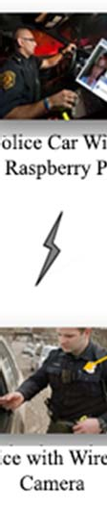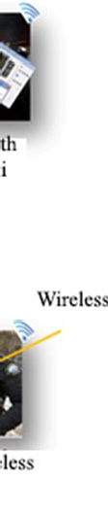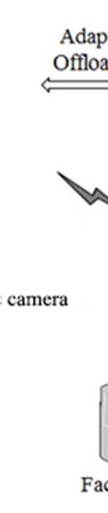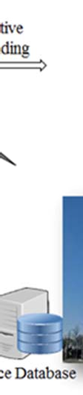

**Figure 1.** Overview of the proposed Ras**p**berry-Pi and cloud aided face recognition framework.

In this framework, face recognition is achieved with a three step process: 1) face detection in a live video stream using the Viola Jones algorithm, 2) feature extraction using BoF with ORB, and 3) face

recognition using a

cloud based support

vector machine (SVM).

The proposed method

has the

competency to easily detect and recognize a face with its corresponding classes. The schematic

representation of the proposed method is shown in Figure 2.

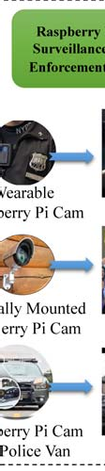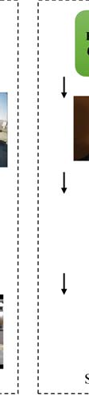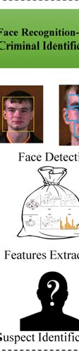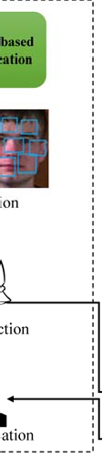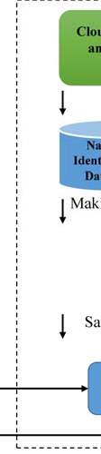

**Figure 2.** Detailed view of the

# 3.1 Real-time Face Detection

roposed face recognition framework for suspect and missing persons identification

Raspberry Pi can be mounted on the shirt of a police officer, on the police van, or located in public places. **I**n the first step, faces are detected in real-time from the videos captured by the Raspberry Pi

camera

using the

Viola Jones

algorithm

as shown in Figure 3.

The Viola

Jones algorithm is

considered to be one of the most efficient algorithms for face detec ion. There **a**re several other face detection algorithms available that can be used to detect faces in real-time. Detailed analysis of these face detection algorithms is presented in [45]. The Viola Jones framework makes use of Haar-based and LBP approaches. The LBP is used as a binary feature descriptor which is usually represented as an unsigned integer. With this approach the performance of object detection is reduced significantly as binary representation is faster to compute and process. Furthermore, the Viola Jones algorithm

proved to be more tolerant of illumination variations. Viola Jones roved to be the best in terms of

performance in real-time videos; however, it is intolerant towards rotation and noise may produce false positives.

some distortions or

After acquiring the face region, ORB points are extracted from the face. Then the SVM classifier is trained in the cloud through the extracted features for the proposed classification.

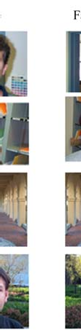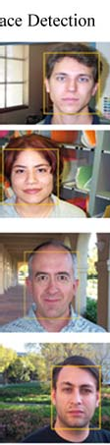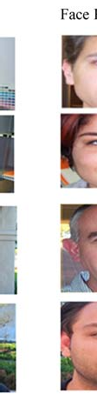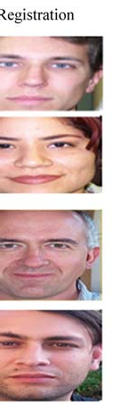

**Figure 3.** Face detection and cropping using the Viola ones algorith m.

# Feature Extraction

Bag of Features, also called Bag of Words (BoW), is a standard feat

re descriptor. In this method, the

local features of training images are extracted using Oriented FAST and Rotated BRIEF (ORB). The

reason

why we use

ORB is that it is fast, robust, and uses a local feature

descriptor for object

recognition, registration, and cl ssification. The working mechanis of ORB with BoF is similar to

SIFT but faster and more robust than SIFT or SURF [46]. Moreover, ORB is less resource intensive in comparison with SIFT and SURF. A detailed comparison of these algorithms are presented in Section 4.

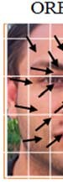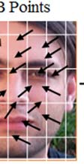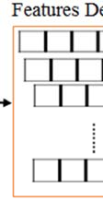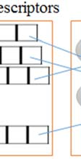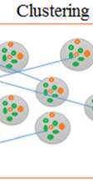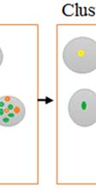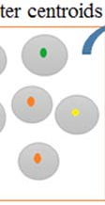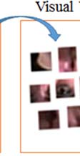

**Figure .** ORB feature extraction using Bag of Words

BRIEF, ORB and BRISK are binary visual descriptors more commonly used. T**h**e main advantage of using these descriptors is that they have less computational cost over its vector-based rivals such as

SIFT and SURF.

The binary

feature des**c**riptor uses

binary numbers and hamming di tance to

compute the distance between two bits. The results are calculated by performing a bitwise XOR

operation and then counting the acquired result. The end result requires less storage space an has less

computational cost as it performs calculations only on bits that can be manipulated by modern systems such as Raspberry Pi, where the hardware support full word instruction, e.g. POPCNT.BRIEF, is a feature descriptor that has been proposed recently. It uses features like SIFT, and it has the same qualities as SIFT. For instance, it is robust in high light situations, distortion of perspective and blurred images. Besides having all these qualities, ORB is more sensitive towards in- plane rotation.

# ORB (Oriented FAST and Rotated BRIEF)

ORB makes use of BRIEF descriptors combined with a FAST keypoints detector. BRIEF stands for Binary Robust Independent Elementary Features, and it is a general purpose detector that can be made an arbitrary detector when combined with other point descriptors. Results of BRIEF on geometric and photometric transformed images are usually robust. BRIEF is designed for embedded and small devices as it takes less computational resources and is ideal for real-time image recognition applications.[47] On the other hand, FAST makes use of the Harris corner measurement technique to find top points (n). It also produces multi-scale features by using pyramids; however, FAST is not rotationally invariant.

For this purpose, ORB introduces few changes to the FAST keypoint descriptor. For rotational invariance, ORB calculates x and y moments in a circular region shaped like a patch of radius r.

*mpq*   *xp yq I* ( *x*, *y*)

*x*, *y*

(1)

To achieve orientation, the intensity weighted centroid is calculated and the direction vector grows towards the centroid from this corner point. A matrix of 2xn is created for any feature set which contains the pixel coordinates (xi, yi), where n is the number of binary tests at a specific location. θ and its rotation matrix is calculated by using orientation of the patch, and S is rotated to get Sθ.

*s*  *m*10 , *m*01

(2)

*m*00 *m*00

ORB computes and increments the angle by 12 degrees (2π/30) at a time and maintains a lookup table. This lookup table contains the already computed patterns of BRIEF. If the orientation of θ across the views is consistent, the descriptors will be computed according to the correct set of Sθ points.

**  *a* tan 2(*m*00 , *m*10 )

(3)

# Cloud-based Training

Cloud computation and storage provides ubiquitous access to service, store, and utilize these resources from a remote location with the least amount of concern regarding mobility or security.

With the revolution of big data, a massive demand of computation, energy, internet bandwidth, and storage is created more than ever before. On the other hand, smart phones, tablets, and other smart devices are often small in size, having less computation power, storage, and limited energy. To overcome these challenges, hybrid approaches are used in which smart devices make use of cloud services for heavy computations such as machine learning model trainings, classifications, and pattern recognitions [16]. There are several cloud vendors, including Google and Microsoft.

Machine learning algorithms generally require large amounts of computation power, memory, and storage other than hardware resources. Besides the resources, these algorithms need a large amount of training datasets for accuracy [29]. However, a large training dataset cannot be loaded into smart devices such as Raspberry Pi, tablets, or smartphones. In order to avoid any damage to the device and improve user experience, a resource aware hybrid-approach is proposed, where the cloud is used as a service to reduce computation cost. The cost of classification is higher than the pre-calculated threshold *T (Tau)*. The formulation of the threshold has already been tested in our previous work [48].

  *e*( *BW* *B* ) \**U*

2 2

(4)

The bandwidth (BW) is usually the key aspect in calculating the overall utilization of energy and resources. The available battery (B) is also considered as we must be aware of the available resources in hand. In our previous work we concluded that the threshold is inversely proportional to the BW and

B. Small values of T will prove to be more efficient in terms of resource utilization. All resources are measured from 1 to 0 i.e. max battery will be indicated by 1 and minimum will be counted as 0. The user preference U is a critical variable. It gives control to the user for better utilization of resources,

i.e. if user is aware of available resources then he can adjust the user preference accordingly.

Using this threshold, additional computational cost is offloaded to the cloud thereby reducing resource usage on the Raspberry Pi. In machine learning, some classifiers offer more robust and accurate classification procedures due to their global properties such as ANN [30] and SVM [31][32]. These techniques become more complex and expensive to process large datasets on smart devices such as Raspberry Pi [33]. In the current technological age, there are various distributed machine learning methods which can be trained on multiple local computers or on a single powerful cloud server. Once trained, these models can be accessed for classification purposes in both local as well as remote locations.

# Results and Discussion

As discussed earlier, the wireless video camera mounted on police officers’ uniforms captures real- time video and streams it back to the Raspberry Pi. The stream of the video is processed frame-by- frame, and the face region is extracted from the real time video using the Viola Jones algorithm [49].

After face detection, the face image is stored locally and forwarded to feature extraction module. Bag of Words descriptor is used to extract ORB points. Once the features are extracted, we determine the cost of the resources needed to classify it locally or on the cloud. The SVM classifier is trained using the same extracted features. This model resides on the cloud and is acceptable using the Google Cloud API provided by most services

# 4.1 System Configuration

The Raspberry Pi device was used to acquire an image stream from the wireless camera. The device was used with the following specification and configuration and hardware details are also given in Table 1. The Raspberry Pi has a Broadcom BCM2837 system on a chip which includes an ARM Cortex-A53, 1.2GHz processor, Video Core IV GPU, and an SD card slot. The GPU of the Raspberry Pi is capable of video playback using H.264 which can play Blu-ray quality videos at 40MBits/s. OpenGL ES2.0 and OpenCV libraries are used to access fast 3D cores. There are several ports present on the Raspberry Pi 3 Model B board including HDMI, 2x2 USB Ethernet, and several others.

**Table 1.** Raspberry Pi software specification for the proposed framework

# Name Configuration

OS Noobs (Raspbian)

Programming Language Python 2.7

Libraries Numpy, SciPy, PyLab, Matplotlib, RPI.GPIO

Imaging Libraries OpenCV 3.1.0, Scikit-Learn, Scikit-Image, MATLAB Support Package for Raspberry Pi

Performance Monitoring Utilities BCMStat, CFML, CommandBox, ContentBox, Line Profiler

Raspbian is the default operating system of the Raspberry Pi and it has more support than any other operating system for the device. Furthermore, the community support for Raspbian is appreciable. As Raspbian is built on the flavour of Debian, it naturally has all the features and compatibilities required for the project. Python 2.7 and 3.5 is already part of the Raspbian operating system and therefore a separate installation is not necessary. The reason that we chose Python 2.7 is because it has more resource community support available and unlike Python 3.5 it is fully compatible with OpenCV 3 and above. The project requires some external Python libraries that need to be installed separately. We have also installed some other performance measurement libraries to evaluate the performance of the code.

# 4.2. Repeatability Measurement

Point-to-point matching of two different

images is

measured i

terms of

repeatability, which

corresponds to the mean number of points matched in two images.

*Cr* 

*C*(*I*1 , *I* 2 )

(5)

12 *mean*(*m* ,*m* )

1

2

Repeatability measurement is

omputed using the above equatio

, where C

(I1, I 2) shows the

corresponding number of points represented in couples, and m1 and m2 are detected points of two images.

means of

the total

These images are evaluated with another evaluation measurement technique c**a**lled RANSAC [50]. This technique is used to remove inconsistent matches, and it takes into account only those points that are inliers. Inliers are those points whose corresponding points are matched in both images. The goal of this technique is to accept all inliers and ignore the outliers. The probability of the algorithm to never get any inlier points in set is 1-P.

1 *P*  (1 *wm* )*k*

(6)

Here, m

is the minimum number of points needed to analyze a model, *w*

is the probability of

RANSAC selecting the inliers a d k is the number of inputs required [50].

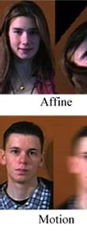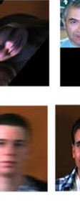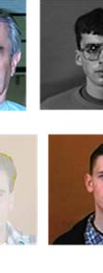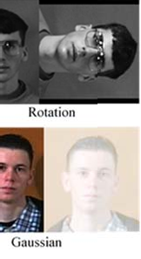

**Figure 5.** As test images we used affine transformed images along with rotation, scaling, gamma, and three types of blurred images. All these general deformations are included by the OpenCV and the same sets of images were used for testing the three different feature extraction techniques.

# 4.3 Face-96, Face-95 and frontal dataset

The Face-96 directory consists of 140 individual face images at 196x196 pixels**.** The only difference in face-95 and face-96 is the change in the background and scale of the face. The background in the face-96 dataset is very complex. The Face-95 dataset consists of 72 male and female individual face images with a red background. Most images are of the frontal face, some with minor side movement, and some of these images consist of some t**r**anslation. The dataset also contains images with lighting variations and some facial expressions. The resolution of each image is 180x200 pixels and they are stored i**n** a JPEG format. The frontal dataset is created by the California Institute of Technology and it

contains a total number of 450 face images at a resolution of 896x592 pixels. The dataset c nsists of

face images of 27 individuals, and the images are stored in a JPEG format. Th**e**se face images have lighting variations, facial expressions, and different backgrounds.

# 4.4. Repeatability Measurement against Noise and Distortion

Images with varying gamma values were used to compare the methods, and the results are presented. For images with varying intensity values, SIFT provides the best matching rate, while ORB has the least. The computational time requirement for ORB is the lowest.

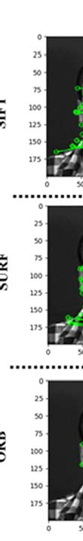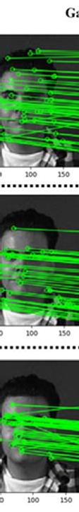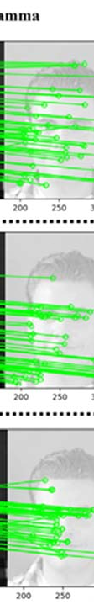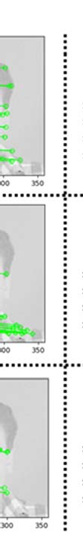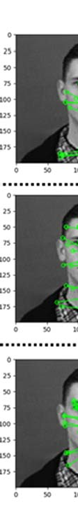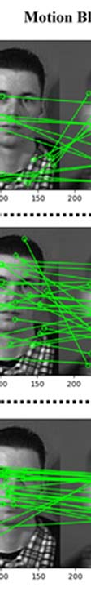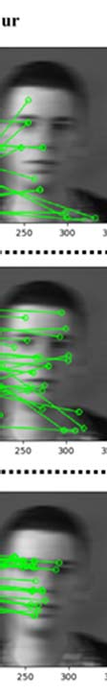

**Figure 6.** Visual results of Gamma and Motion Blur

The influence of blur is measured on the

images and results were compared

in the tables below.

Consistent with the

previous experiments,

the first 10 matches

were considered. The radius of

Gaussian blur was gradually increased from 0 to 9.0, and the results were measured. As shown in the

graph below the proposed method performs well and has the most correct matches. Besides the

Gaussian blur, Motion and Median blur were also tested, and the number of matches were higher in

the proposed ORB method. An increase of Gamma has no effect on both SURF and SIFT enhances the matching ratio of ORB up to the value of 2.5 Gamma.

while it

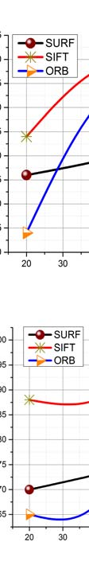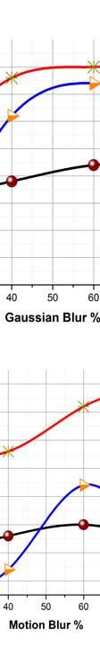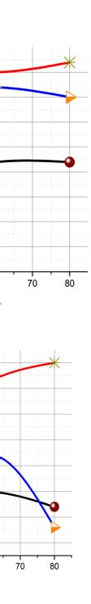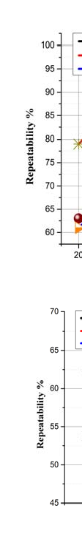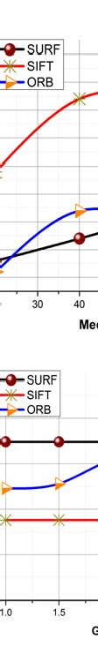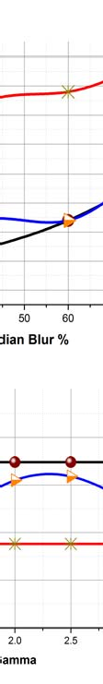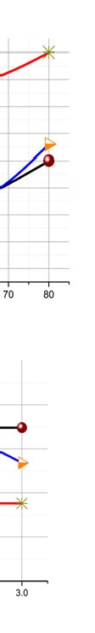

**Figure 7.** Noise analysis of the three methods.

The repeatability measurement of algorithms were tested against different kinds of blurs and the points collected by SIFT were more accurate than any other method. The mai**n** problem with SIFT was that the number of points collected were not enough to train a successful model. The only method whose collected points were nearly good to train the model was ORB. The number of points collected by ORB were more than SURF, and it helped the model to be more accurate than SURF.

**Sc**

**Rotatio**

**Affine**

**SIFT**

**SURF**

**Figure 8.** Visual results of scale, rotation and affine transformation i**n**variance

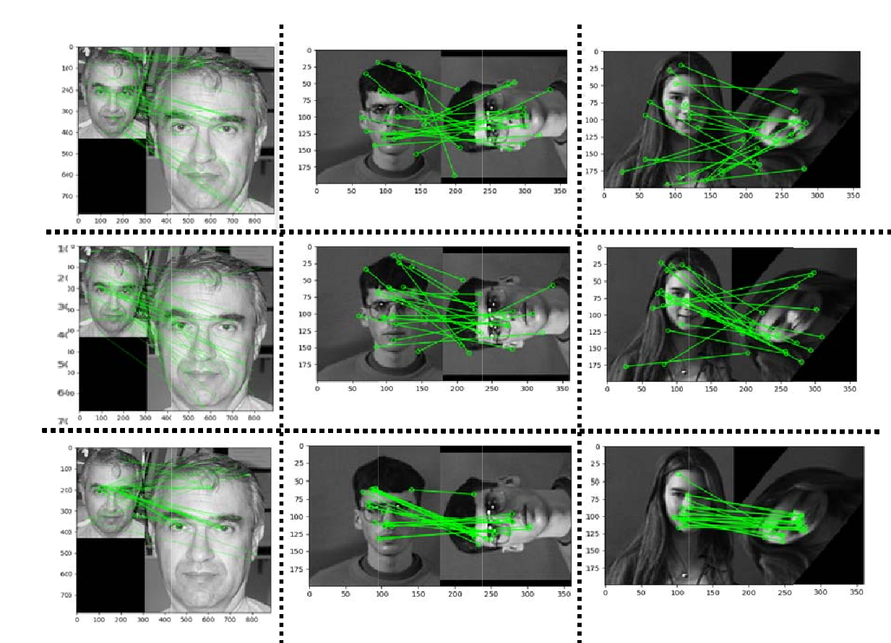

**aling**

**n**

**ORB**

In this experiment, we evaluate he performance of the proposed system by using scale invar ance. As

shown in Figure 8, the number of matches for all three algorithms are clear. Consistent with the

previous experiment, the number of matches is based on the first 10 whose distance is the least. As the scale of the image is changed, we observe that the proposed method outperforms the SIFT or SURF. The data is presented as the number of matches with the increase in number of images. Further, the set of images were tested and the influence of rotation is analyzed. As shown in Figure 8, the images were rotated by 5 to 10 degrees, and then the first 10 matches are observed.

SIFT performs well in terms of rotation and had the most stable results. On the other hand, SURF did not perform well and hence has the least nu**m**ber of matches. The number of matches for the proposed system is not better than SIFT, and hence **i**t can be improved by tuning the p**a**rameters. In another

experiment, the stability of the methods is evaluated when the affin transformation is changed. This

transformation is usually important where the images need to be stitched together, e.g. in a panorama. The results are measured in terms of transformation ratio as it is increased from 0 to 50 degrees. SURF and SIFT work well when this ratio is small; however, for larger numbers the proposed method is significantly better.

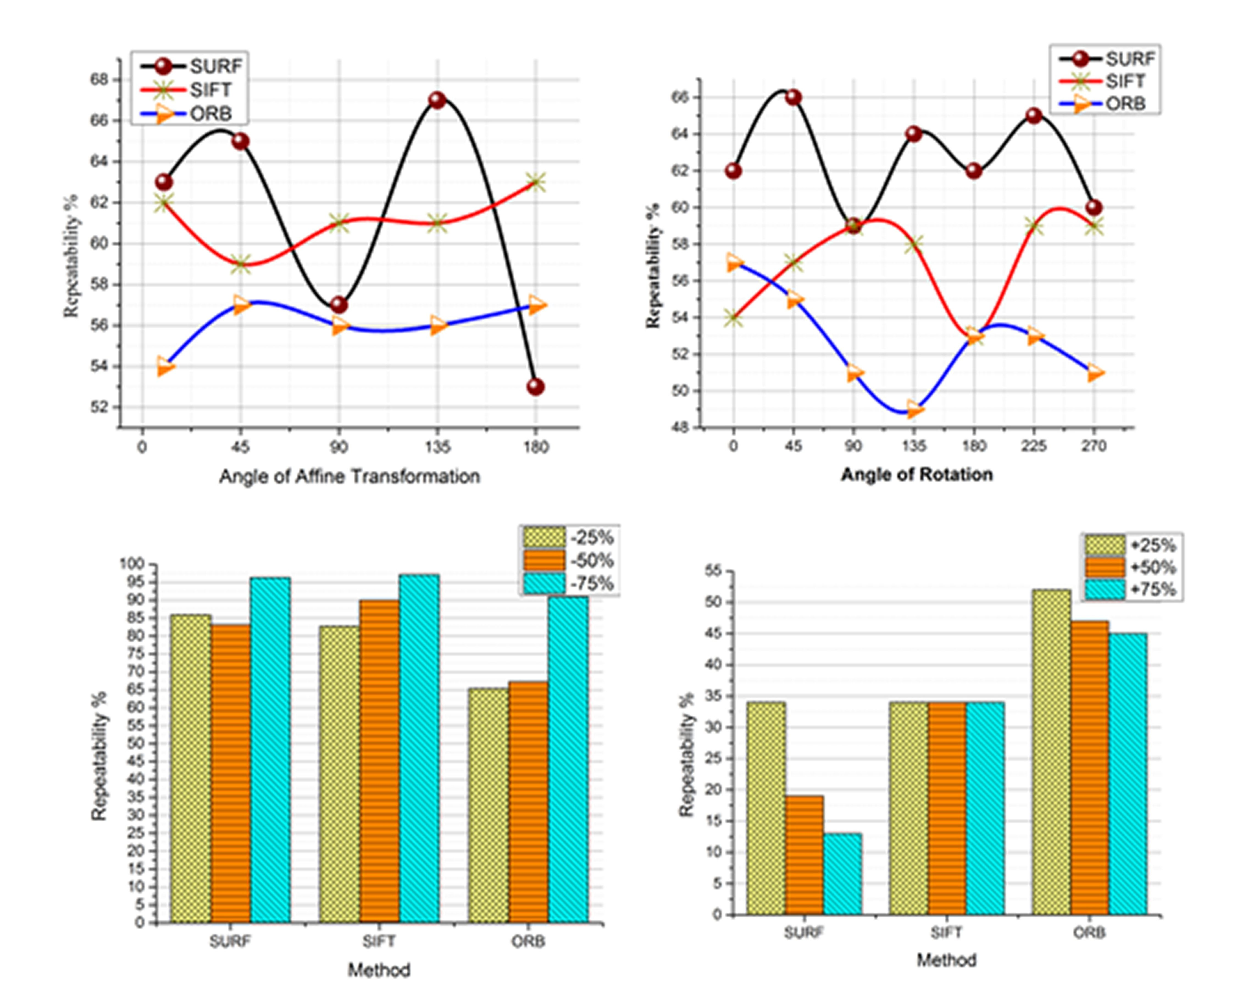

**Figure 9.** Comparative analysis of SURF, SIFT and ORB on scaling

Changes in the perspective and geometric transformation of the image affect the algorithm performance. We tested the same sets of images with different deformations. The results suggest that a change in affine affects ORB the most, and the number of matches reduced to less than 55%. On the other hand, the results of SURF and SIFT were better. Similarly, in the case of rotation, ORB performed moderately better while SIFT shows promising results. We test the images against both scaling up and scaling down to see if there is any significant change between the results. As we can see by scaling up, the performance of ORB is significantly better than SIFT or SURF, while on scaled down images the performance is inconclusive.

# Time Analysis of SURF, SIFT and ORB

Evaluation of time is always relative as it depends on multiple factors e.g. the size, quality and texture of the image. It also depends on the settings and parameters of the algorithm for instance the size of k or the distance ratio etc. Figure 10 shows the average amount of time spent to detect the first 10 matches. All images are sized 300x240 and are captured from the live video stream of the Raspberry Pi camera. Initial parameters of each algorithm are set as default meaning as proposed in their respective original papers.

Time is measured for both feature detection and matching. As mentioned in Figure 10, the proposed method is relatively fast.

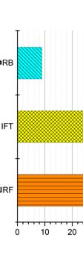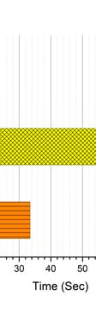

**Figure 10.** Time analysis of SURF, SIFT and ORB

# Experimental Evaluation

Our proposed face recognition system is tested on a benchmarked dataset discussed earlier. The grid size for feature selection is 8x8, and the block width is [32, 64, 96, 128] pixels. For the feature quantization, the number of clusters used are 500 and 250 with cross validation 0.7 and 0.3; 0.7 for training and 0.3 for testing. The experiment was conducted on frontal images from Face 95 and Face

96 face

datasets. From the given dataset,

only the faces were extracted and

classified into their

respective class. The results were then compared with the originals to calculat**e** the accuracy of the proposed face recognition technique.

**Table 2.** Results of the propose

**r**

method on Face-95 with different no. of images and cross validation and k- size.

|  |  |  |  |  |  |
| --- | --- | --- | --- | --- | --- |
| **No: classes** | **T aining** | **k-size** | **Cross validation** | **No: of features** | **Average Acc racy** |
| 70 | 30 | 500 | 0.7 | 364,320 | 100 |
| 70 | 30 | 500 | 0.3 | 850,080 | 99 |
| 70 | 05 | 500 | 0.7 | 60,720 | 92 |
| 70 | 05 | 500 | 0.3 | 121,440 | 89.3 |

**Table 3.** Results of the proposed method on Face-95 with different cross validation and k- size.

|  |  |  |  |  |  |
| --- | --- | --- | --- | --- | --- |
| **No: classes** | **Testing** | **K- size** | **Cross validation** | **No: of features** | **Accuracy %** |
| 70 | 30 | 500 | 0.3 | 179,162 | 96.8 |
| 70 | 30 | 500 | 0.7 | 422,163 | 98.4 |
| 70 | 05 | 500 | 0.3 | 32,219 | 86.3 |
| 70 | 05 | 500 | 0.7 | 61,417 | 88.7 |

**Table 4.** Results of the proposed method on Face-95 with different no. of images and cross validation and k- size.

|  |  |  |  |  |  |
| --- | --- | --- | --- | --- | --- |
| **No: classes** | **Training** | **k-size** | **Cross validation** | **No: of features** | **Accuracy %** |
| 33 | 20 | 500 | 0.7 | 858,000 | 98.7 |
| 33 | 20 | 500 | 0.3 | 330000 | 95.0 |
| 33 | 05 | 500 | 0.7 | 132000 | 89.1 |
| 33 | 05 | 500 | 0.3 | 66000 | 79.1 |

**Table 5.** Results of the proposed method on Face-95 with different no. of images and cross validation and k- size.

|  |  |  |  |  |  |
| --- | --- | --- | --- | --- | --- |
| **No: classes** | **Training** | **k-size** | **Cross validation** | **No: of features** | **Accuracy %** |
| 70 | 30 | 250 | 0.7 | 427,639 | 98.3 |
| 70 | 30 | 250 | 0.3 | 164,393 | 96.2 |
| 70 | 05 | 250 | 0.7 | 43,266 | 83.1 |
| 70 | 05 | 250 | 0.3 | 21,346 | 71.2 |

**Table 6**. Perspective transformation and its effects on the proposed method.

|  |  |  |  |  |  |  |
| --- | --- | --- | --- | --- | --- | --- |
| **Method** | **Noise Effects** | | **Perspective Transformation** | | | **Other** |
|  | *Blurring Effect* | *Gamma Variations* | *Scale Variations* | *Rotational Changes* | *Affine Transformation* | *Time Analysis* |
| SURF | Ordinary | Ordinary | Ordinary | Ordinary | Good | Good |
| SIFT | Good | Ordinary | Good | Good | Good | Ordinary |
| Proposed | Best | Best | Good | Ordinary | Best | Best |

The results of all experiments on test images are shown in the above tables. There is no single method that performs best in all deformations. Hence, choosing the right feature extraction method strictly depends on the type of data and the performance of the method. In our case, the results of these experiments were not constant, varying according to the image texture, size, color intensity, scaling, and transformation effects. The results also varied when the size of the clusters were altered or the parameters of RANSAC were changed.

The number of features collected by SIFT is huge, and hence the matching success is also satisfactory because of the reduced localization errors. However, the problem with using SIFT on Raspberry Pi is the time and memory it took to compute these features. On the other hand, SURF outperforms SIFT in time, and the matching ratio of SURF collected points were far better than SIFT. The only issue with SURF points was that it did not perform in both Gamma variation as well as with blurred images. As surf uses Fast-Hassian detectors the collection speed of SURF is almost 3 times as fast compared to SIFT [51]. ORB among all three performs best in regard to time. Its feature extraction time is almost 3 times as fast as SIFT and twice as fast as SURF. Furthermore, the SVM model trained with collection of points extracted by ORB were significantly better than SIFT or SURF. The time complexity and lower computational resource requirement makes this method ideal for small devices like Raspberry Pi.

# Conclusion

Real-time suspect detection and recognition without interaction with the subject is a challenging task. Face recognition technology and the embedded processing capabilities of portal devices such as Raspberry Pi can significantly help law enforcement agencies in the identification of suspects in a cost effective manner. This necessitates the requirement of an efficient framework for simplifying the suspect recognition process. With this motivation, we have proposed an efficient suspect identification framework using cloud services and Raspberry Pi, which can extract suspect’s face from the video stream captured by a uniform-mounted camera from the police officer. Raspberry Pi not only provides an expedient platform for detection and feature extraction, but also reliably communicates with the cloud for assistance where necessary. The proposed framework automatically extracts the face using the Viola Jones algorithm, followed by feature extraction using the ORB algorithm, which is significantly better than SURF and SIFT as proved in our experiments. The cost of computing features of the face region is calculated and used as a threshold for adapting offloading. A binary SVM model is trained and a portion of it is stored locally to classify suspects. The experimental evaluation suggests that ORB has significant advances over SIFT and SURF as it is more robust and is ideal for processors with limited capabilities. The performance of the proposed system is further analysed by introducing different noises and variations. Quantitative and qualitative evaluation using three different datasets validate the effectiveness of the proposed framework for enhancing the effectiveness of law-enforcement services in smart cities.

In the future, we will investigate convolution neural networks and deep belief networks and their performance on Raspberry Pi for suspect identification. Furthermore, we are planning to conduct detailed analysis of face detection algorithms on real-time video streams and its performance on the Raspberry Pi device. The use of a better classifier will definitely increase the performance of the

algorithm, and in the future we will investigate different variants of SVM and present a comparative analysis on Raspberry Pi.

# 5. Acknowledgement

This research is supported by: Start-up Research Grant Program through Research and Development Division (R & D Division) funded by Higher Education Commission of Pakistan (21- 1498/SRGP/R&D/HEC/2016) and National Research Foundation of Korea (NRF) grant funded by the Korean government (MSIP) (No.2016R1A2B4011712).

# References

1. Wang, Y., R. Chen, and D.-C. Wang, *A survey of mobile cloud computing applications: perspectives and challenges.* Wireless Personal Communications, 2015. **80**(4): p. 1607-1623.
2. Biswas, K. and V. Muthukkumarasamy. *Securing Smart Cities Using Blockchain Technology*. in *High Performance Computing and Communications; IEEE 14th International Conference on Smart City; IEEE 2nd International Conference on Data Science and Systems (HPCC/SmartCity/DSS), 2016 IEEE 18th International Conference on*. 2016. IEEE.
3. Nguyen, A., J. Yosinski, and J. Clune. *Deep neural networks are easily fooled: High confidence predictions for unrecognizable images*. in *Proceedings of the IEEE Conference on Computer Vision and Pattern Recognition*. 2015.
4. Mandal, B., et al. *A wearable face recognition system on google glass for assisting social interactions*. in *Asian Conference on Computer Vision*. 2014. Springer.
5. Wang, X., et al. *Computerized-eyewear based face recognition system for improving social lives of prosopagnosics*. in *Pervasive Computing Technologies for Healthcare (PervasiveHealth), 2013 7th International Conference on*. 2013. IEEE.
6. Chen, S., A. Pande, and P. Mohapatra. *Sensor-assisted facial recognition: an enhanced biometric authentication system for smartphones*. in *Proceedings of the 12th annual international conference on Mobile systems, applications, and services*. 2014. ACM.
7. Parmar, D.N. and B.B. Mehta, *Face recognition methods & applications.* arXiv preprint arXiv:1403.0485, 2014.
8. Houmb, S.H., et al., *An integrated security verification and security solution design trade-off analysis approach.* Integrating Security and Software Engineering: Advances and Future Visions/Mouratidis, Haralambos, 2007: p. 190-219.
9. Yang, J., et al., *Two-dimensional PCA: a new approach to appearance-based face representation and recognition.* IEEE transactions on pattern analysis and machine intelligence, 2004. **26**(1): p. 131-137.
10. Kumar, M.S.S. and R. Swami, *An improved face recognition technique based on modular LPCA approach.* 2011.
11. Yang, M., et al., *Monogenic binary coding: An efficient local feature extraction approach to face recognition.* IEEE Transactions on Information Forensics and Security, 2012. **7**(6): p. 1738-1751.
12. Corcoran, P.M. and C. Iancu, *Automatic Face Recognition System for Hidden Markov Model Techniques*. 2011: INTECH Open Access Publisher.
13. Sermanet, P., et al., *Overfeat: Integrated recognition, localization and detection using convolutional networks.* arXiv preprint arXiv:1312.6229, 2013.
14. Zhang, H., et al. *SVM-KNN: Discriminative nearest neighbor classification for visual category recognition*. in *Computer Vision and Pattern Recognition, 2006 IEEE Computer Society Conference on*. 2006. IEEE.
15. Wang, J., et al. *Locality-constrained linear coding for image classification*. in *Computer Vision and Pattern Recognition (CVPR), 2010 IEEE Conference on*. 2010. IEEE.
16. Sajjad, M., et al., *Leukocytes Classification and Segmentation in Microscopic Blood Smear: A Resource-Aware Healthcare Service in Smart Cities.* IEEE Access, 2016.
17. Sajjad, M., et al., *Mobile-cloud assisted framework for selective encryption of medical images with steganography for resource-constrained devices.* Multimedia Tools and Applications, 2017. **76**(3): p. 3519-3536.
18. Muhammad, K., M. Sajjad, and S.W. Baik, *Dual-Level Security based Cyclic18 Steganographic Method and its Application for Secure Transmission of Keyframes during Wireless Capsule Endoscopy.* Journal of Medical Systems, 2016. **40**(5): p. 114.
19. Muhammad, K., et al., *A novel magic LSB substitution method (M-LSB-SM) using multi-level encryption and achromatic component of an image.* Multimedia Tools and Applications, 2016. **75**(22): p. 14867-14893.
20. Viola, P. and M. Jones. *Rapid object detection using a boosted cascade of simple features*. in *Computer Vision and Pattern Recognition, 2001. CVPR 2001. Proceedings of the 2001 IEEE Computer Society Conference on*. 2001. IEEE.
21. Jones, P., P. Viola, and M. Jones. *Rapid object detection using a boosted cascade of simple features*. in *University of Rochester. Charles Rich*. 2001. Citeseer.
22. Wolf, L. *Deepface: Closing the gap to human-level performance in face verification*. in

*Computer Vision and Pattern Recognition (CVPR), 2014 IEEE Conference on. IEEE*. 2014.

1. Taigman, Y., et al. *Deepface: Closing the gap to human-level performance in face verification*. in *Proceedings of the IEEE Conference on Computer Vision and Pattern Recognition*. 2014.
2. Varun, R., et al., *Face Recognition Using Hough Transform Based Feature Extraction.*

Procedia Computer Science, 2015. **46**: p. 1491-1500.

1. üge Çarıkçı, M. and F. Özen, *A Face Recognition System Based on Eigenfaces Method.*

Procedia Technology, 2012. **1**: p. 118-123.

1. Xie, S., et al., *Learned local Gabor patterns for face representation and recognition.* Signal Processing, 2009. **89**(12): p. 2333-2344.
2. Yaji, G.S., et al., *Dwt feature extraction based face recognition using intensity mapped unsharp masking and laplacian of gaussian filtering with scalar multiplier.* Procedia Technology, 2012. **6**: p. 475-484.
3. Yang, S., et al., *Effective face recognition using bag of features with additive kernels.* Journal of Electronic Imaging, 2016. **25**(1): p. 013025-013025.
4. Juan, L. and O. Gwun, *A comparison of sift, pca-sift and surf.* International Journal of Image Processing (IJIP), 2009. **3**(4): p. 143-152.
5. Chowdhury, N., S. Nooman, and S. Sarker, *Access Control of Door and Home Security by Raspberry Pi Through Internet.* Int. J. Sci. Eng. Res, 2013. **4**: p. 550-558.
6. Xu, Z., et al., *Raspberry Pi Based Intelligent Wireless Sensor Node for Localized Torrential Rain Monitoring.* Journal of Sensors, 2016. **2016**.
7. Shah, D., *IoT Based Biometrics Implementation on Raspberry Pi.* Procedia Computer Science, 2016. **79**: p. 328-336.
8. Agrawal, N. and S. Singhal. *Smart drip irrigation system using raspberry pi and arduino*. in *Computing, Communication & Automation (ICCCA), 2015 International Conference on*. 2015. IEEE.
9. Atick, J.J., P.A. Griffin, and A.N. Redlich, *Continuous video monitoring using face recognition for access control*. 2000, Google Patents.
10. Sethia, D., S. Singh, and V. Singhal, *ABE Based Raspberry Pi Secure Health Sensor (SHS)*, in *Advances in Ubiquitous Networking 2: Proceedings of the UNet’16*, R. El-Azouzi, et al., Editors. 2017, Springer Singapore: Singapore. p. 599-610.
11. Imteaj, A., et al. *An IoT based fire alarming and authentication system for workhouse using Raspberry Pi 3*. in *2017 International Conference on Electrical, Computer and Communication Engineering (ECCE)*. 2017.
12. Chungki, W., et al. *Auto charging platform and algorithms for long-distance flight of drones*. in *2017 IEEE International Conference on Consumer Electronics (ICCE)*. 2017.
13. Zdraveski, V., et al., *Dynamic Load Balancing and Reactive Power Compensation Switch Embedded in Power Meters.* IEEE Transactions on Circuits and Systems II: Express Briefs, 2017. **64**(4): p. 422-426.
14. Chorowski, J., J. Wang, and J.M. Zurada, *Review and performance comparison of SVM-and ELM-based classifiers.* Neurocomputing, 2014. **128**: p. 507-516.
15. Zhang, Y., et al., *Magnetic resonance brain image classification via stationary wavelet transform and generalized eigenvalue proximal support vector machine.* Journal of Medical Imaging and Health Informatics, 2015. **5**(7): p. 1395-1403.
16. Zhang, Y., et al., *Preclinical diagnosis of magnetic resonance (MR) brain images via discrete wavelet packet transform with Tsallis entropy and generalized eigenvalue proximal support vector machine (GEPSVM).* Entropy, 2015. **17**(4): p. 1795-1813.
17. Zhang, Y.D., et al., *Magnetic resonance brain image classification based on weighted‐type fractional Fourier transform and nonparallel support vector machine.* International Journal of Imaging Systems and Technology, 2015. **25**(4): p. 317-327.
18. Zhang, Y. and L. Wu, *Classification of fruits using computer vision and a multiclass support vector machine.* Sensors, 2012. **12**(9): p. 12489-12505.
19. Phillips, P.J. *Support vector machines applied to face recognition*. in *Advances in Neural Information Processing Systems*. 1999.
20. Fasel, I.R. and J.R. Movellan. *A comparison of face detection algorithms*. in *International Conference on Artificial Neural Networks*. 2002. Springer.
21. Panchal, P., S. Panchal, and S. Shah, *A comparison of SIFT and SURF.* International Journal of Innovative Research in Computer and Communication Engineering, 2013. **1**(2): p. 323- 327.
22. Rublee, E., et al. *ORB: An efficient alternative to SIFT or SURF*. in *Computer Vision (ICCV), 2011 IEEE International Conference on*. 2011. IEEE.
23. Mehmood, I., M. Sajjad, and S.W. Baik, *Mobile-cloud assisted video summarization framework for efficient management of remote sensing data generated by wireless capsule sensors.* Sensors, 2014. **14**(9): p. 17112-17145.
24. Viola, P. and M.J. Jones, *Robust real-time face detection.* International journal of computer vision, 2004. **57**(2): p. 137-154.
25. Vinay, A., et al., *Feature Extractionusing ORB-RANSAC for Face Recognition.* Procedia Computer Science, 2015. **70**: p. 174-184.
26. Karami, E., S. Prasad, and M. Shehata, *Image Matching Using SIFT, SURF, BRIEF and ORB: Performance Comparison for Distorted Images.* Faculty of Engineering and Applied Sciences, Memorial University, Canada.

**Authors’ Biographies**



**Muhammad Sajjad** received his Master degree from Department of Computer Science, College of Signals, National University of Sciences and Technology, Rawalpindi, Pakistan. He received his PhD degree in Digital Contents from Sejong University, Seoul, Republic of Korea. He is

now working as an assistant

professor

at Department of Computer Science, Islamia College

Peshawar, Pakistan. He is also head of “Digital Image Processing Laboratory (DIP Lab)” at

Islamia College Peshawar, Pakistan. His research interests include digital image super-resolution and reconstruction, medical image analysis, video summarization and prioritization, image/video quality assessment, and image/video retrieval.



**Mansoor Nasir** received his MS degree in Computer Science from Institute of Management

Sciences, Peshawar, Pakistan. He is currently pursuing PhD

course from Islamia

College,

Peshawar, Pakistan. His research interest include, Network Security, Distributed Systems and Trusted Computing.



**Khan Muhammad** received his BS degree in computer science from Islamia College, Peshawar,

Pakistan with research in information security. Currently, he is pursuing MS leading to PhD

degree in digitals contents from College of Software Convergence, Sejong University, Seoul, Republic of Korea. He is working as a researcher at Intelligent Media Laboratory (IM Lab). His research interests include image and video processing, wireless networks, information security, image and video steganography, video summarization, diagnostic hysteroscopy, wireless capsule

endoscopy, and

CCTV video analysis. He has

published

24+ papers in peer-reviewed

international journals and conferences in these research areas. He is a student member of the IEEE.



**Siraj Khan** received his BCS degree from University of Peshawar, Pakistan in the field of

computer science.

Currently,

he is doing Master

degree in

computer science from Islamia

College

Peshawar, Pakistan.

He is an

active member of

Digital Image Processing Lab,

Department of Computer Science, Islamia College Peshawar. His research interests include

image processing, image segmentation, image classification and healthcare services.

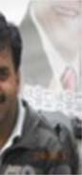

**Zahoor**

**Jan** is currently holding the rank of an

associate professor in

computer

science at

Islamia College Peshawar, Pakistan. He received his MS and PhD degree from FAST University

Islamabad in 2007 and 2011

respectively. He is also chairman of Department of

Computer

Science at Islamia College Peshawar, Pakistan. His areas of interests include image processing,

machine learning,

computer

vision, artificial intelligence and medical image processing,

biologically inspired ideas like genetic algorithms and artificial neural networks, and their soft-

computing applications, biometrics,

solving image/video

restoration problems using

combination of classifiers using genetic digital watermarking and image fusion.

programming, optimization of

shaping functions in



**Arun**

**Kumar Sangaiah** has

received

his Doctor

of Philosophy (PhD)

degree in

Computer

Science and Engineering from the VIT University, Vellore, India. He is presently working as an Associate Professor in School of Computer Science and Engineering, VIT University, India. His

area of

interest includes software engineering, computational

intelligence, wireless

networks,

bio-informatics, and embedded systems. He has authored more than 100 publications in different journals and conference of national and international repute. His current research work includes global software development, wireless ad hoc and sensor networks, machine learning, cognitive networks and advances in mobile computing and communications. Also, he was registered a one Indian patent in the area of Computational Intelligence. Besides, Prof. Sangaiah is responsible for Editorial Board Member/Associate Editor of various international journals.



**Mohamed Elhoseny** completed his B.S in Computer and Information Sciences from Mansoura

Univeristy, Faculty of Computers and Information, Egypt. Then, Dr. Elhoseny received his

Ph.D. in Computer and Information Sciences from Mansoura University Egypt (in a scientific research channel with Department of Computer Science and Engineering**,** University of North

Texas,

USA ). His Ph.D. thesis was awarded the

best PhD thesis prize

(2016) at

Mansoura

University. Dr. Elhoseny is currently an Assistant Professor at the Faculty of Computers and

Information, Mansoura University, Egypt where

he also teaches several courses

such as

“Security in Computing”, "Mobile Computing", and “Information Theory”. Collectively, Dr. Elhoseny authored/co-authored over 50 International Journal articles, Conference Proceedings,

Book Chapters, and 1 Springer brief book. His research interests include Network Security,

Cryptography, Machine Learning Techniques, Internet of Things, and Quantum Computing. He

has several publications in reputed and Springer, and others.

high impact journals published

by IEEE,

Elsevier,



**Sung Wook Baik** received the B.S degree in computer science from Seoul National University, Seoul, Korea, in 1987, the M.S. degree in computer science from Northern Illinois University,

Dekalb, in 1992,

and the Ph.D. degree

in information technology engineering from George

Mason University, Fairfax, VA, in 1999. He worked at Datamat Systems Research Inc. as a senior scientist of the Intelligent Systems Group from 1997 to 2002. In 2002, he joined the faculty of the College of Electronics and Information Engineering, Sejong University, Seoul, Korea, where he is currently a Full Professor and Dean of Digital Contents. He is also the head of Intelligent Media Laboratory (IM Lab) at Sejong University. His research interests include computer vision, multimedia, pattern recognition, machine learning, data mining, virtual reality, and computer games. He is a member of the IEEE.

**Highlights**

* 1. A novel Raspberry Pi based cloud assisted framework is proposed for suspect detection and recognition. Suspect is identified in video streams which passively facilitate law enforcement agencies to provide better safety in smart cities.
  2. Viola Jones face detector is incorporated in the proposed framework, providing efficient face detection results compared to state-of-the-art schemes. Furthermore, the Viola Jones face detection algorithm is computationally inexpensive, making it more suitable for Raspberry Pi based framework.
  3. The proposed system considers ORB points as extracted from the detected face region for face recognition. ORB technique uses fast binary descriptor based on BRIEF, and is rotationally invariant. Further, it is effective and computationally feasible for embedded and smart devices such as smart phones, tablets and Raspberry Pi, where resources are limited.
  4. Our framework uses an SVM model which is trained on cloud to recognize faces into their respective classes. Instead of sending the entire face images, only extracted features are transmitted to cloud server, saving the transmission energy and bandwidth. This makes our system more affordable and implementable for security in smart cities.